**Aeratron AE3**

**\*Embodied carbon for aluminum and ABS plastic taken from ICE database.**

|  |  |  |  |
| --- | --- | --- | --- |
| [**Components**](https://en.wikipedia.org/wiki/Ceiling_fan#Parts_of_a_ceiling_fan)**[1]** | **Dimensions** | **Value** | Assumption |
| Blades (3)- ABS plastic | 43”- 197.8 in sq  50”- 230 in sq  60”- 276 in sq |  |  |
| Equilateral Triangle | 30.324 |  |  |
| 43” inch SA | 228.124*.042 pounds per cubic inch sq= 6.0 pounds per cubic inch, 2.721 kilograms | 2.721 kilograms * 3.05 kg co2/ kg of ABS = 8.29 |  |
| 50” inch SA | 260.24*.042 pounds per cubic inch sq=6.5 pounds per cubic inch, 2.94 kilograms | 2.94* 3.05 kg co2/ kg of ABS = 8.967 |  |
| 60” inch SA | 306.324*.042 pounds per cubic inch sq= 6.7 pounds per cubic inch, 3.03 kilograms | 3.03 * 3.05 kg co2/ kg of ABS = 9.24 kg co2 |  |
| Aluminum motor 43” | 9.58- 6.0 = 3.58 pounds per cubic inch sq | 3.58 * 8.24 kg CO2 / kg of Aluminum = 29.5 |  |
| Aluminum motor 50” | 10.9- 6.5= 4.4 pounds per cubic inch sq | 4.4 * 8.24 kg CO2 / kg of Aluminum = 36.256 |  |

Aluminum motor 60” 12.86- 6.7 = 6.16 6.16 * 8.24 kg CO2 / kg of Aluminum = 50.7

pounds per cubic inch sq

Totals:

AE3-43” = 8.29 +29.5= 37.8

AE3-50” = 8.967 + 36.256 = 45.2

AE3-60” = 9.24 + 50.7 = 59.9

|  |  |
| --- | --- |
| PC/ABS | .042 |

pounds per cubic inch

Blades Assumptions

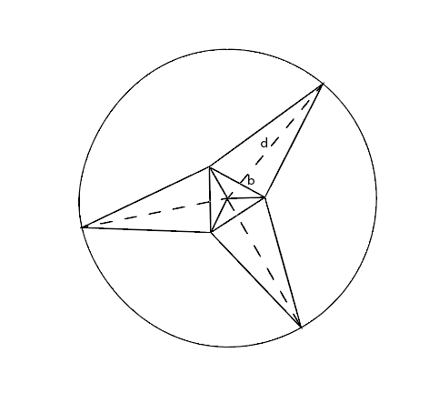

Equilateral triangle formula:

√3/4(9.2)^2 =1.4/4*9.2^2=0.35*84.64* = 30.324 sq in

Blades area calculation:

.5*(9.2)*(43)=197.8

.5*(9.2)*50=230

.5*(9.2)*60= 276

1. Assume that these are the only components of the ceiling fan